Types of movies vocabularies

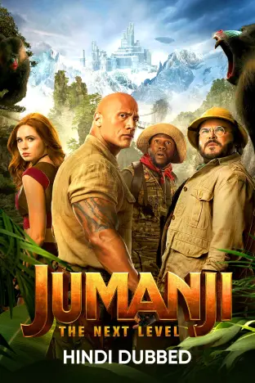
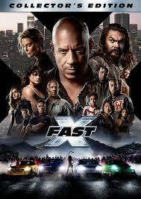
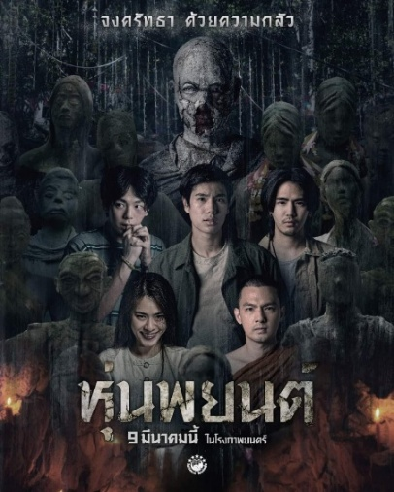

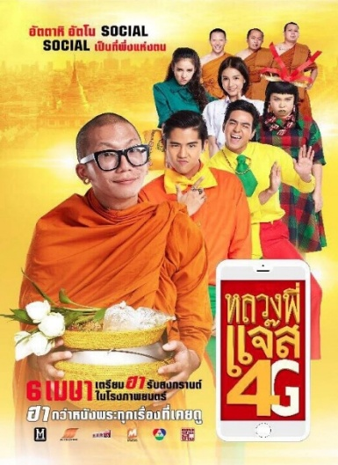
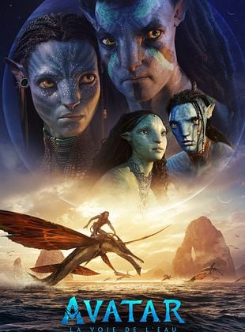
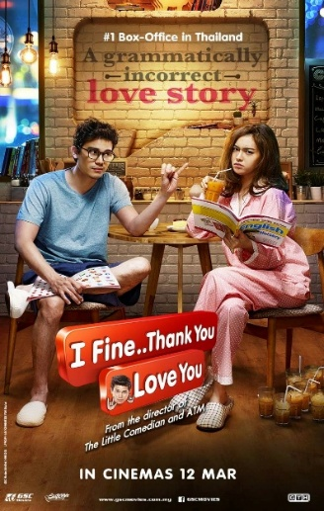

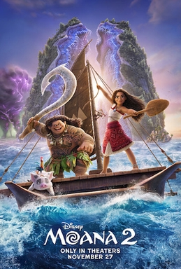
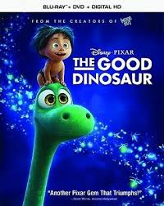
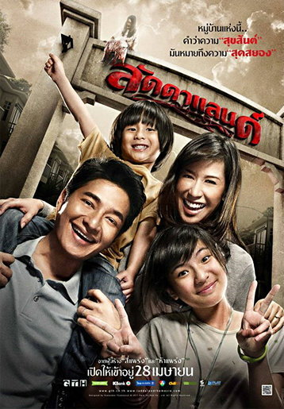

Going to the cinema script

Tamara: Hi, Mario. Do you want to go and watch a film?
Mario: Hi, Tamara. Sure, what’s on?
Tamara: Well, there are two action films, Mr and Mrs Jones and War Games, and they’re both in 3D.
Mario: I’ve already seen Mr and Mrs Jones. I haven’t seen War Games, but I don’t really want to see an action film. What else is on?
Tamara: There’s that science fiction film, Robot 2075, but I’ve already seen it.
Mario: Is it good?
Tamara: Yes, it is, but I don’t want to see it again. There’s a romantic comedy called Forever.
Mario: Mmm, I’m not sure. Are there any horror films on?
Tamara: Yes, there’s Midnight Moon. It’s got vampires in it.
Mario: OK, sounds good. Let’s go and watch Midnight Moon. What time is it on?
Tamara: It’s on at 12 o’clock or at half past two.
Mario: Is it on this evening?
Tamara: Yes, at 7:30.
Mario: Perfect. Let’s go at 7:30.
Tamara: OK, shall we meet at the cinema at 7:00?
Mario: Great! See you later.
Tamara: Bye.

Missing phrases
- Do you want to go and watch a film
- what’s on?
- two action films
- science fiction film
- Is it good?
- romantic comedy
- Are there any horror films on?
- Let’s go and watch Midnight Moon.
- half past two.
- Is it on this evening?



Checking movie again!

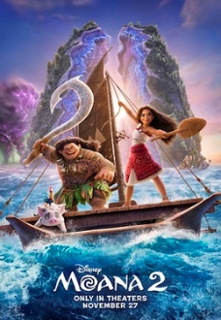
………………………………………………………….
- ……………………………………………………
- ……………………………………………………
………………………………………………………….
- ……………………………………………………
- ……………………………………………………

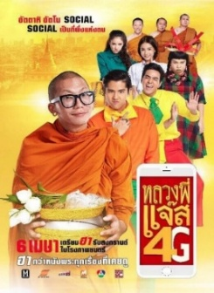

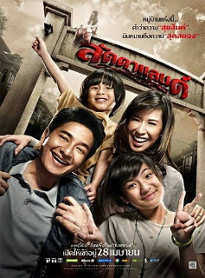
………………………………………………………….
- ……………………………………………………
- ……………………………………………………
………………………………………………………….
- ……………………………………………………
- ……………………………………………………
………………………………………………………….
- ……………………………………………………
- ……………………………………………………
………………………………………………………….
- ……………………………………………………
- ……………………………………………………
………………………………………………………….
- ……………………………………………………
- ……………………………………………………
………………………………………………………….
- ……………………………………………………
- …………………………………………………… ………………0

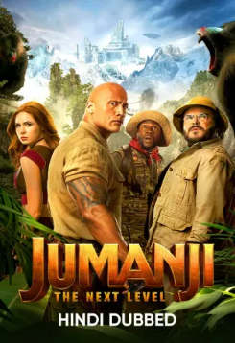

Name ………………………………………………………………………………………number…………………………

